Website Development Method

For a complete and basic html page or webpage, these must be containing head and body section. For the head section, it contain texts and tags yet do not show directly into the page. In the other section, texts and tags that contain into the body section and yet it will be shown directly into the page.

Figure 1

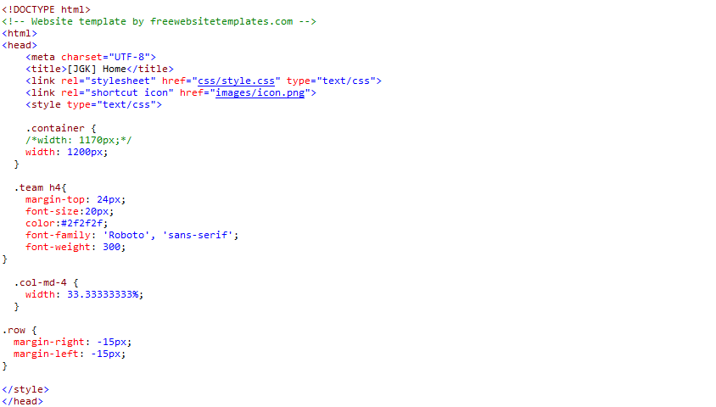

Let start with the head section, first thing first it must contain the title of the webpages. And yet, there are containing the internal and external cascading style sheet (CSS) which is a webpage derived from multiple sources with a defined order of precedence where the definitions of any style element conflict. So in our webpage title name “[JGK] Home” which will be shown at the tab on the browser and JGK (JG Kourier) is our name of webpage. In addition, there have 4 event of internal CSS which to holding the source of webpage.

Figure 2 ()

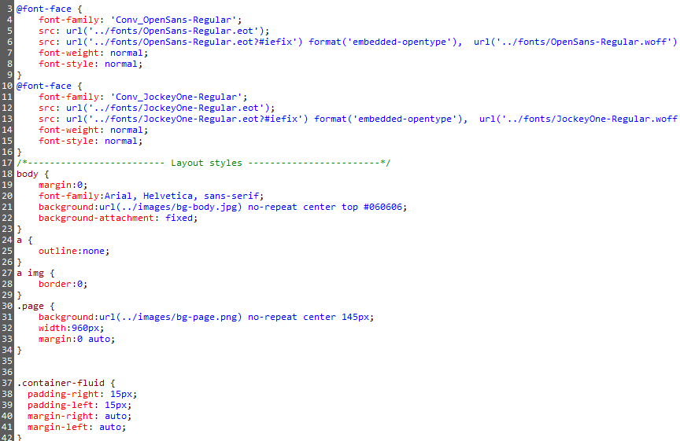

So the external CSS which is shown as figure 2, there are holding the huge amount of the webpages’ source. You have to link the CSS file with the HTML, so back to the head section, you have to type a tag which is attach the external CSS file to HTML, example <link rel="stylesheet" href="css/style.css" type="text/css">, “css” in the tag is the location of the CSS where are storing and “style.css” is the name if CSS file.

With that being said, internally written CSS will always overwrite the attached external CSS to avoid scripting conflicts.